[CSE341 Lecture on 2021-09-27 - Part 1 of 2](https://youtu.be/cdSkmYxx2O4)

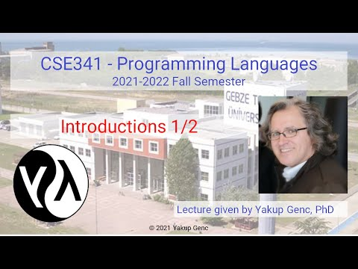

[CSE341 Lecture on 2021-09-27 - Part 2 of 2](https://youtu.be/CFlvxqdcJsE)

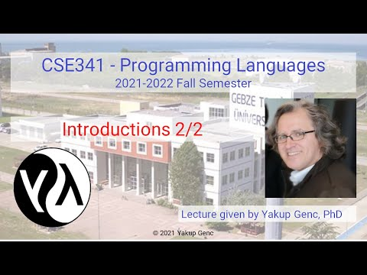

[CSE341 Lecture on 2021-10-04 - Part 1 of 2](https://youtu.be/oaWbOV1X_U0)

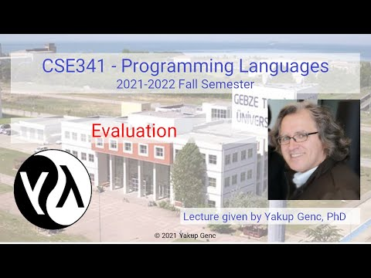

[CSE341 Lecture on 2021-10-04 - Part 2 of 2](https://youtu.be/4HyyLsHta5E)

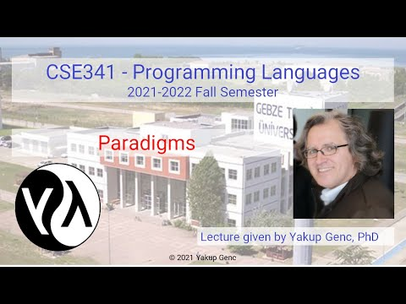

[CSE341 Lecture on 2021-10-06 - Part 1 of 2](https://youtu.be/9kQyPW2H-dk)

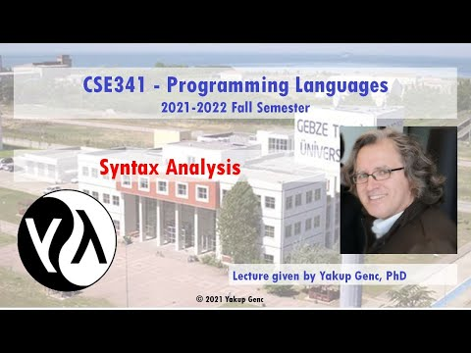

[CSE341 Lecture on 2021-10-06 - Part 2 of 2](https://youtu.be/rEFzHGo98jI)

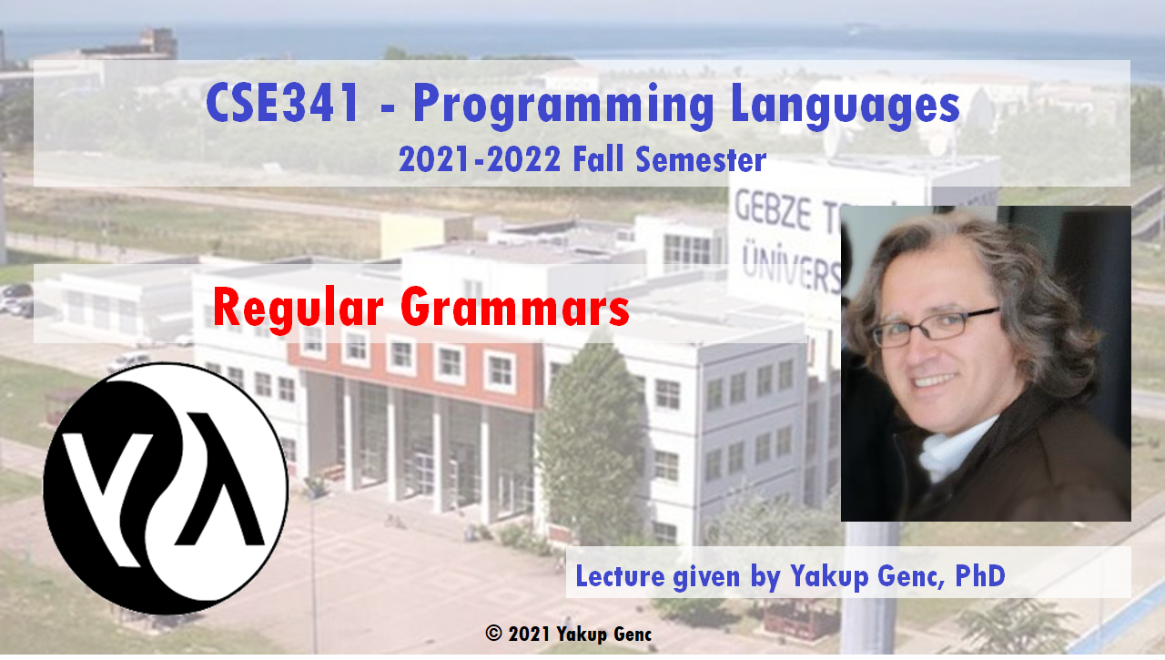

[CSE341 Lecture on 2021-10-11 - Part 1 of 2](https://youtu.be/IscpoLehrWc)

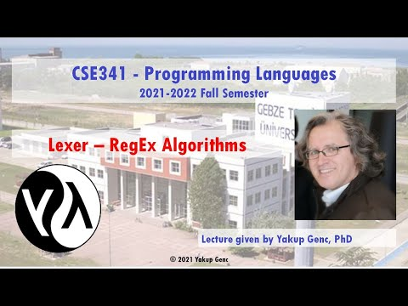

[CSE341 Lecture on 2021-10-11 - Part 2 of 2](https://youtu.be/O1_flohUs8c)

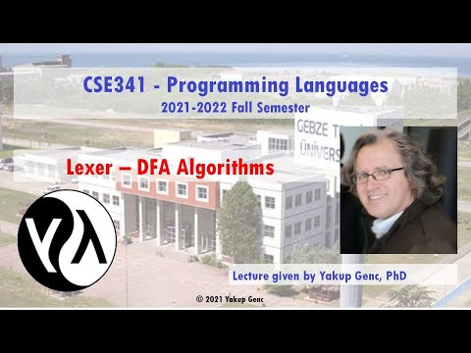

[CSE341 Lecture on 2021-10-13 - Part 1 of 2](https://youtu.be/PhqoakdwzXE)

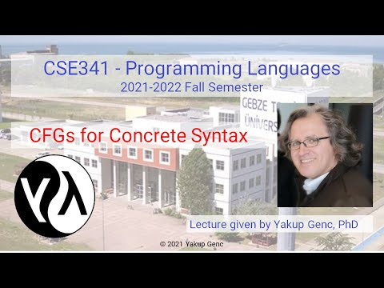

[CSE341 Lecture on 2021-10-13 - Part 2 of 2](https://youtu.be/RgKoxi7f3lM)

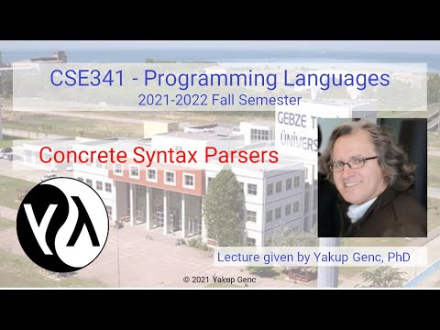

[CSE341 Lecture on 2021-10-18 - Part 1 of 2](https://youtu.be/LedjaDkzBt0)

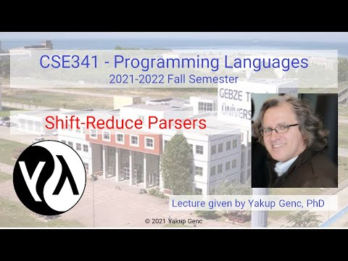

[CSE341 Lecture on 2021-10-18 - Part 2 of 2](https://youtu.be/PinHtRSuiGg)

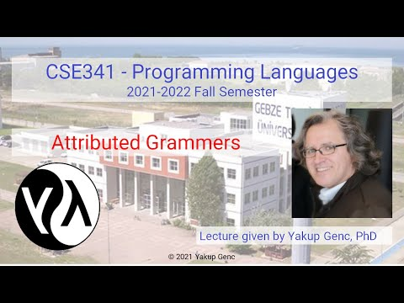

[CSE341 Lecture on 2021-10-20 - Part 1 of 2](https://youtu.be/8aS9jGSjtCU)

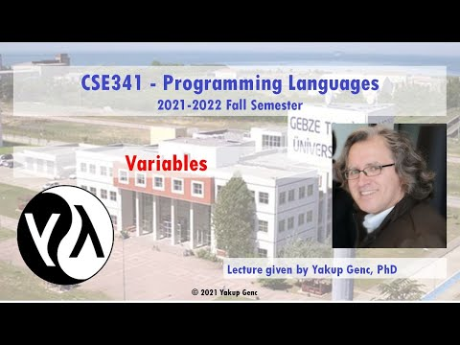

[CSE341 Lecture on 2021-10-20 - Part 2 of 2](https://youtu.be/0R9EnbO_cpk)

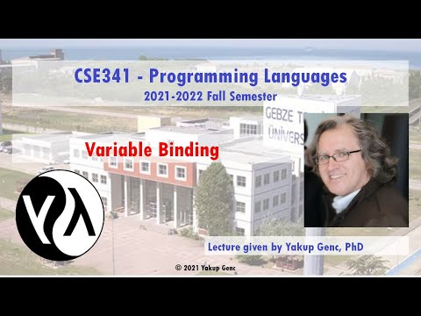

[CSE341 Lecture on 2021-11-01 - Part 1 of 2](https://youtu.be/a1Y3OIQ-crA)

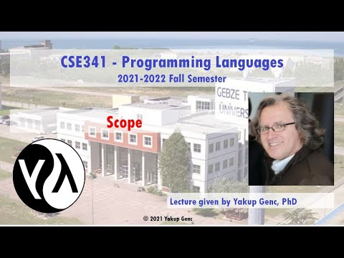

[CSE341 Lecture on 2021-11-01 - Part 2 of 2](https://youtu.be/Hzh5Xn_Zucw)

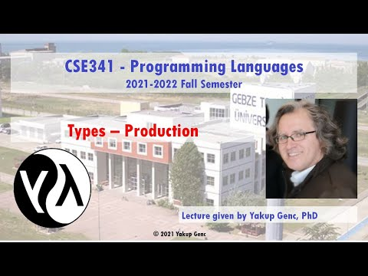

[CSE341 Lecture on November 3, 2021 - Part 1 of 2](https://youtu.be/CWmvux0odAk)

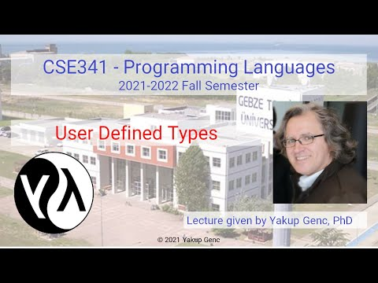

[CSE341 Lecture on November 3, 2021 - Part 2 of 2](https://youtu.be/dL5-9JDjgvU)

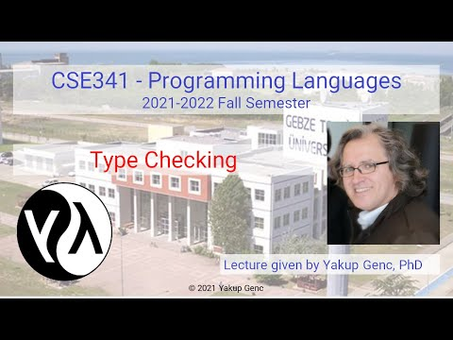

[CSE341 Lecture on November 8, 2021 20211108 143647](https://youtu.be/96tNwMZ8HPk)

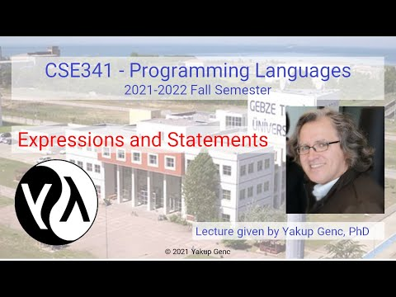

[CSE341 Lecture on November 8, 2021 20211108 153155 Meeting Recording](https://youtu.be/blRzYU5E2CQ)

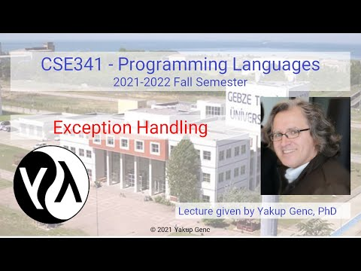

[CSE341 Lecture on 2021-11-15 - Part 1 of 2](https://youtu.be/l02lzF2lGsk)



[CSE341 Lecture on 2021-11-15 - Part 2 of 2](https://youtu.be/xiM-0U9ilDs)



[CSE341 Lecture on 2021-11-17 - Part 1 of 2](https://youtu.be/bbfsq9T8z0E)

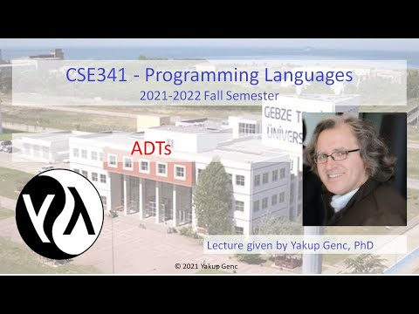

[CSE341 Lecture on 2021-11-17 - Part 2 of 2](https://youtu.be/Qm0BXqYxavo)

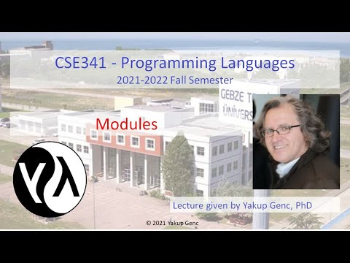

[CSE341 Lecture on 2021-11-24 - Part 1 of 2](https://youtu.be/5ICQCgZEeMY)

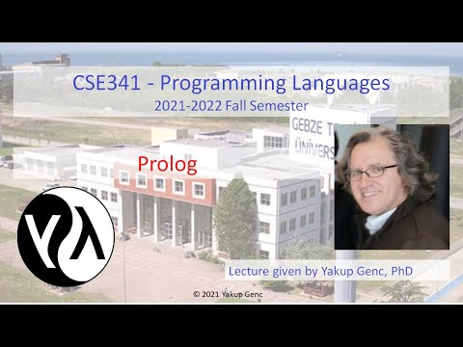

[CSE341 Lecture on 2021-11-24 - Part 2 of 2](https://youtu.be/lSgxB1gnvu0)



[CSE341 Lecture on 2021-11-29 - Part 1 of 2](https://youtu.be/IORDOkPCYb4)

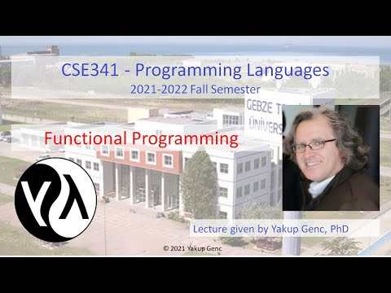

[CSE341 Lecture on 2021-11-29 - Part 2 of 2](https://youtu.be/5ZchOdhzpgk)

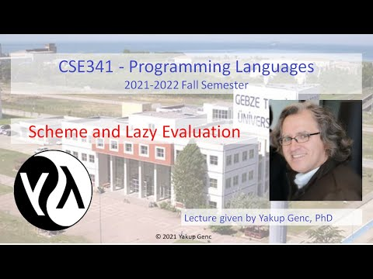

[CSE341 Lecture on 2021-12-01 - Part 1 of 2](https://youtu.be/Gzu8rEIn7xg)

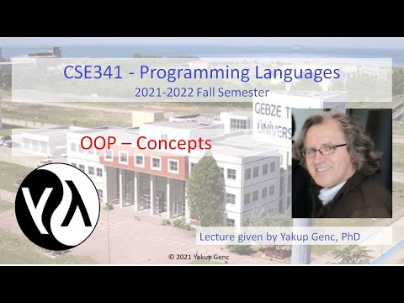

[CSE341 Lecture on 2021-12-01 - Part 2 of 2](https://youtu.be/IbDhapC7WeA)

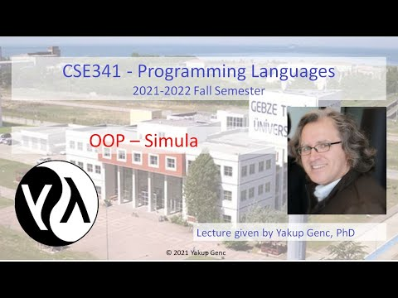

[CSE341 Lecture on 2021-12-06 - Part 1 of 2](https://youtu.be/dZgGN5sifeE)

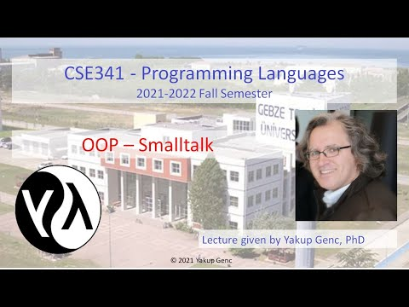

[CSE341 Lecture on 2021-12-06 - Part 2 of 2](https://youtu.be/LEhbC8i3Wxg)

